

DEPARTMENT OF COMPUTER SCIENCE AND ENGINEERING

CS23432 – Software Construction
(REGULATION 2023)
RAJALAKSHMI ENGINEERING COLLEGE
Thandalam, Chennai-602015

Name: Sukirthan Udhayakumar
Register No: 240701546
Year / Branch / Section: II / CSE
Semester: IV
Academic Year: 2025 - 2026

INDEX
S.No. | Date | Title
1. | 07-02-2026 | Azure DevOps Environment Setup
2. | 14-02-2026 | Azure Project Setup & User Stories
3. | 21-02-2026 | Epics, Features, User Stories Creation
4. | 28-02-2026 | Sprint Planning using Azure Boards
5. | 07-03-2026 | Poker Estimation using Azure Boards.
6. | 14-03-2026 | Designing Class and Sequence Diagrams for Product Category Management System.
7. | 04-04-2026 | Designing Architectural and ER Diagrams for Product Category Management System.
8. | 11-04-2026 | Testing – Test Suites and Test Cases in Azure.
9. | 18-04-2026 | Load Testing and CI/CD Pipeline Setup.
10. | 25-04-2026 | GitHub: Project Structure & Naming Conventions.

EXP NO: 01
AZURE DEVOPS ENVIRONMENT SETUP

Create Epic, Features, User Stories, Task

Aim:
To set up and access the Azure Devops environment by creating an account and workspace for project management.

INSTALLATION
- Open your web browser and go to: https://dev.azure.com
Sign in using your Microsoft account credentials.
If you do not have an account, create one using Sign Up option. .
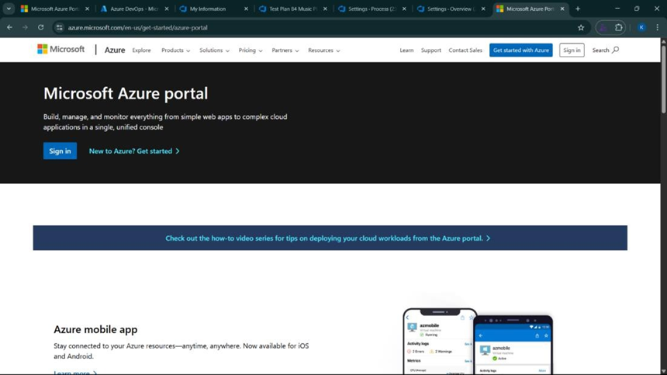

2. Azure Devops home page
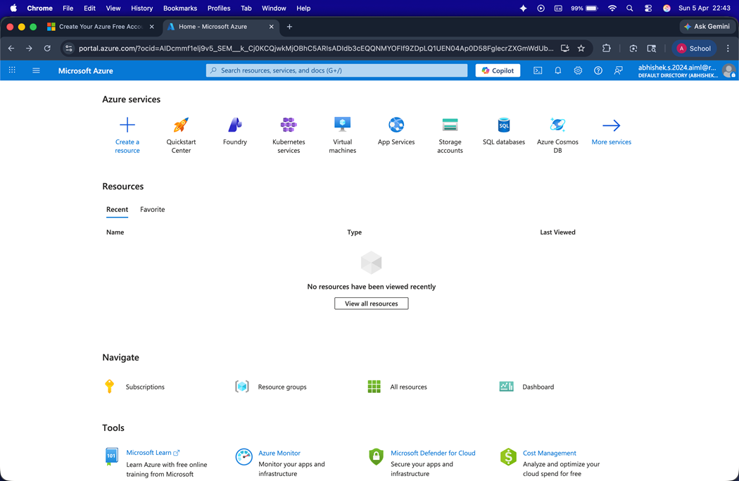
3. Open DevOps environment in the Azure platform by typing Azure DevOps Organizations in the search bar.

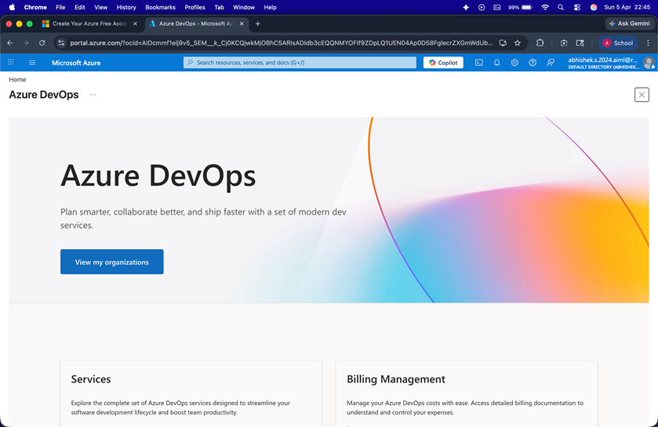

4. Click on New Project, create a new organization/project, and access the Azure DevOps dashboard successfully..
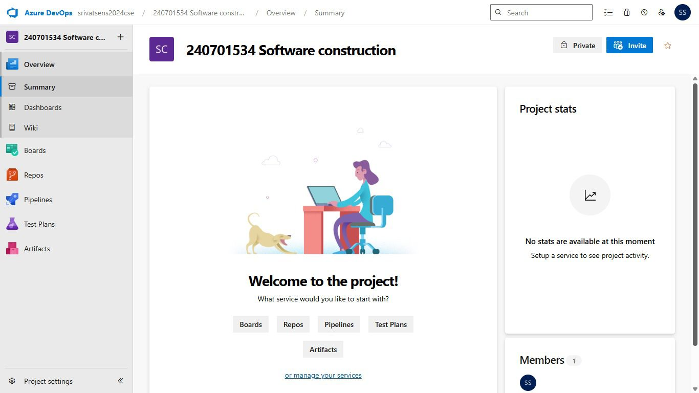

Result:

Successfully accessed the Azure environment and created a new workspace/site for project management.
EXP NO: 02
AZURE PROJECT SETUP AND USER STORY MANAGEMENT

Create Epic, Features, User Stories, Task

Aim:
To set up an Azure DevOps project for efficient collaboration and agile work management.

• Create an Azure DevOps Account
• Create the First Project in Your Workspace
a. After setup, create your first project.
b. Click New Project
c. Enter details:
Name: Product Category Management System
Description: Category handling system
Template: Scrum
Access: Private/Open
d. Click Create
• Open project dashboard
• Project dashboard
• To manage user stories:
a. Go to Boards → Work Items
b. Click New Work Item → User Story
c. Enter details

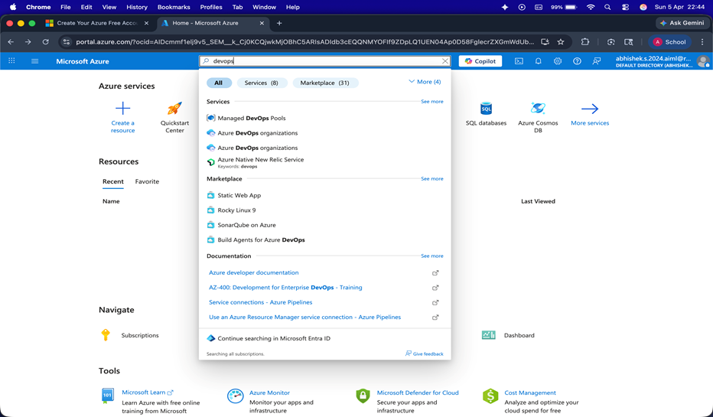

Result: Successfully created an Azure DevOps project with user story management
EXP NO: 03
EXP NO: 3
SETTING UP EPICS, TASKS, AND USER STORIES FOR PROJECT PLANNING

Create Epic, Features, User Stories, Task

Aim:
To learn about how to create epics, tasks, user stories, and backlogs for your assigned project.

Create Epic, User Stories, Task
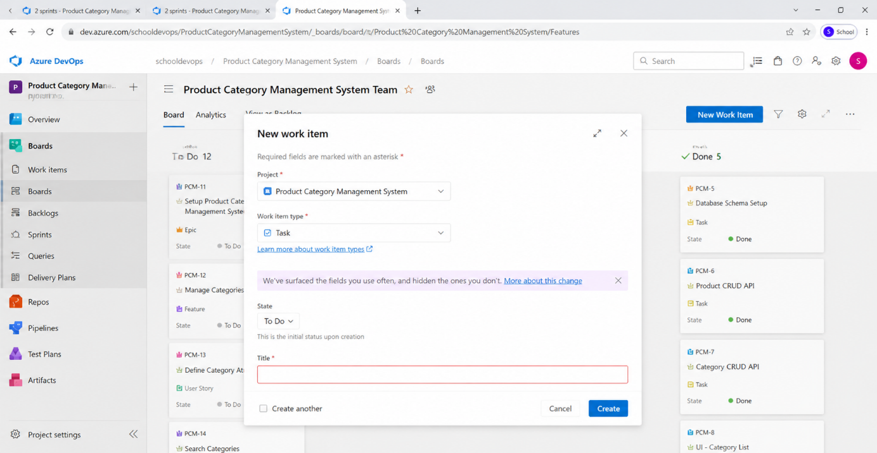
1.Fill in Epics
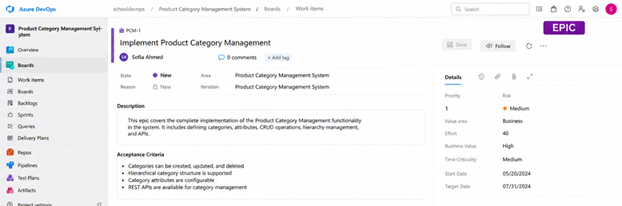

2.Fill in Features


3.Fill in User Story Details
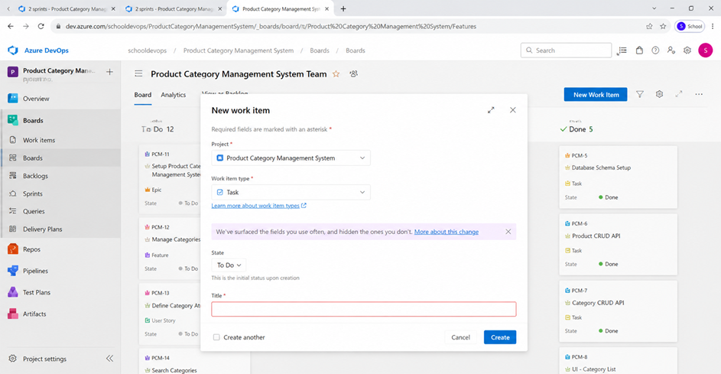

Result:
Thus, the creation of epics, features, user story and task has been created successfully.
EXP NO: 04
EXP NO: 4
SPRINT PLANNING IN AZURE

Create Epic, Features, User Stories, Task

Aim:
To assign user story to specific sprint for the Product Category Management System

Sprint Planning
- Open Boards → Sprints
- Create:
  - Sprint 1
  - Sprint 2
- Drag user stories into sprint

Sprint 1

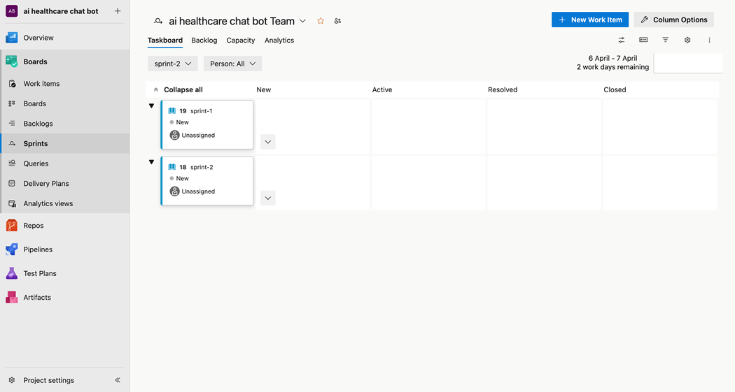
Sprint 2

Result:
The Sprints are created for the Product Category Management System.

EXP NO: 05
EXP NO: 5

POKER ESTIMATION USING AZURE

Create Epic, Features, User Stories, Task

Aim:
Create Poker Estimation for the user stories – Product Category Management System.

Poker Estimation

Points | Meaning
1 | Trivial – minor UI text change, config tweak
2 | Simple – single form field, small validation rule
3 | Small – single API endpoint, basic DB query
5 | Medium – feature with frontend + backend + DB
8 | Large – complex feature with multiple integrations
13 | Very Large – cross-system feature, high uncertainty
21 | Epic – needs breaking down before sprint

Procedure:
- Assign points:
  - Add Category → 3
  - Delete Category → 2
  - Search → 1

Sprint | Total SP | Duration | Velocity | Focus
Sprint 1 | 39 SP | 2 weeks | ~20 SP/dev/sprint | Core auth + chatbot + symptom analysis
Sprint 2 | 62 SP | 2 weeks | ~31 SP/dev/sprint | Voice, maps, admin, monitoring, CI/CD

Result:
The Estimation/Story Points is created for the project using Poker Estimation.

EXP NO: 06
5EXP NO: 5EXP NO: 5EXP NO: 6
DESIGNING CLASS AND SEQUENCE DIAGRAMS FOR PRODUCT CATEGORY MANAGEMENT SYSTEM

Create Epic, Features, User Stories, Task

Aim:
To Design a Class Diagram and Sequence Diagram for the given Product Category Management
System.
6A. Class Diagram
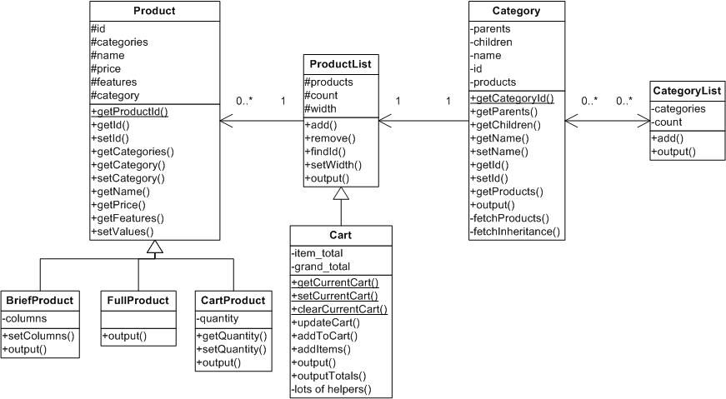

6B. Sequence Diagram

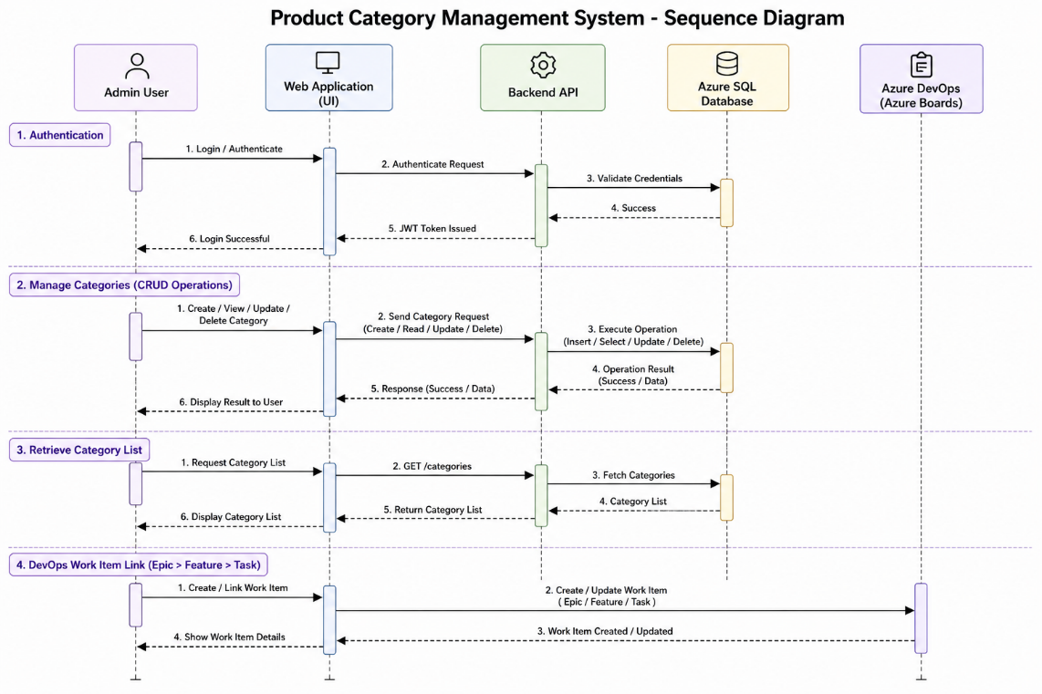

Result:The Class Diagram and Sequence Diagram is designed Successfully for the Product Category Management System

EXP NO: 5EXP NO: 5EXP NO: 5
EXP NO: 07

DESIGNING ARCHITECTURAL AND ER DIAGRAMS FOR PRODUCT TRACKING SYSTEM

Create Epic, Features, User Stories, Task

Aim:
To Design an Architectural Diagram and ER Diagram for the given Project.
7 A. Architectural Diagram
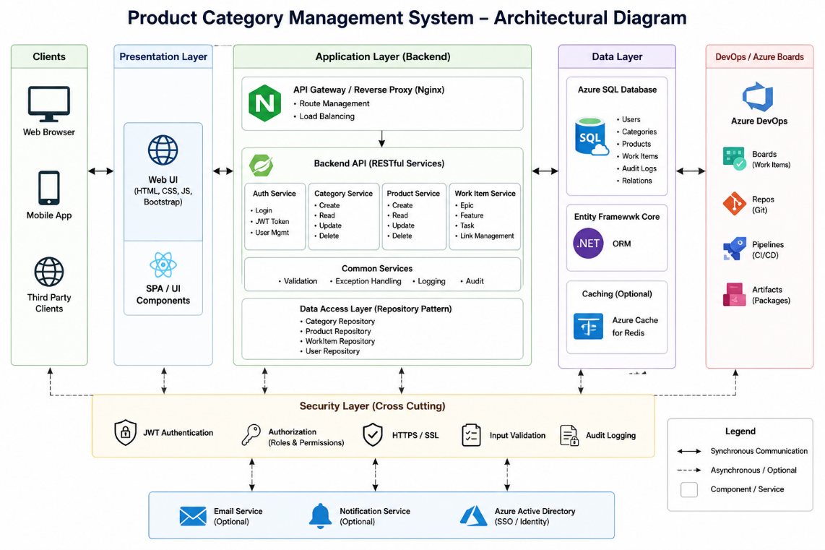

7 B. ER Diagram
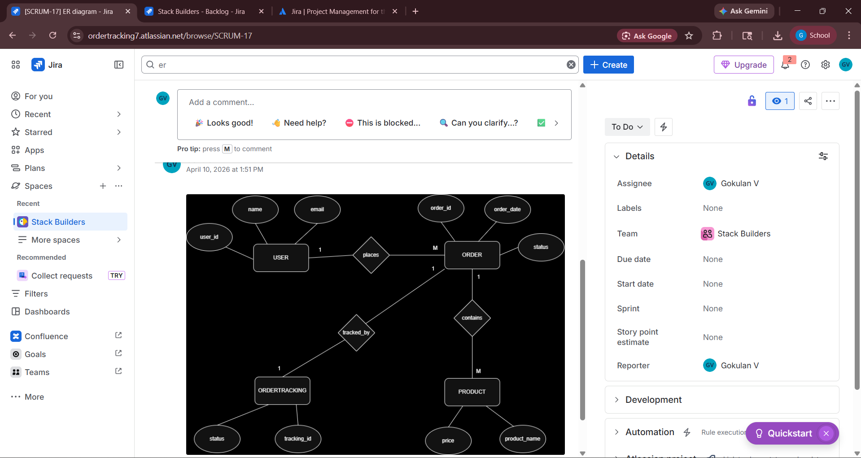

Result
The Architecture Diagram and ER Diagram is designed Successfully for the Product Category Management System
.

EXP NO: 08

TESTING – TEST SUITES AND TEST CASES IN AZURE

Create Epic, Features, User Stories, Task

Aim:
To create Test plans and Test Cases, and write two test cases for atleast five user stories showcasing happy path and error scenarios in the Azure platform.

Test Planning and Test Case
Test Case Design Procedure
- Understand Core Features of the Application
  - User Signup & Login
  - Place New Product
  - Track Product Status
  - View Product Details
  - Admin Product Management
- Define User Interactions
  - Each test case simulates a real user behaviour
- Design Happy Path Test Cases
  - Focused on validating that all features function as expected under normal conditions.
- Design Error Path Test Cases
  - Simulate negative or unexpected scenarios to test robustness and error handling.
- Break Down Steps and Expected Results
  - Each test case contains step-by-step actions and a corresponding expected outcome.
  - Ensures clarity for both testers and automation scripts.
- Use Clear Naming and IDs
  - Test cases are named clearly (e.g., TC01 – Successful Login, TC04 – Invalid Product Tracking).
  - Helps in quick identification and linking to user stories.

- Separate Test Suites
  - Grouped test cases based on functionality (e.g., Login Management, Product Management,
  - Improves organization and test execution flow in Azure.
- Prioritize and Review
  - Critical user actions are marked high-priority.
  - Reviewed for completeness and traceability against project requirements.

- Test suite
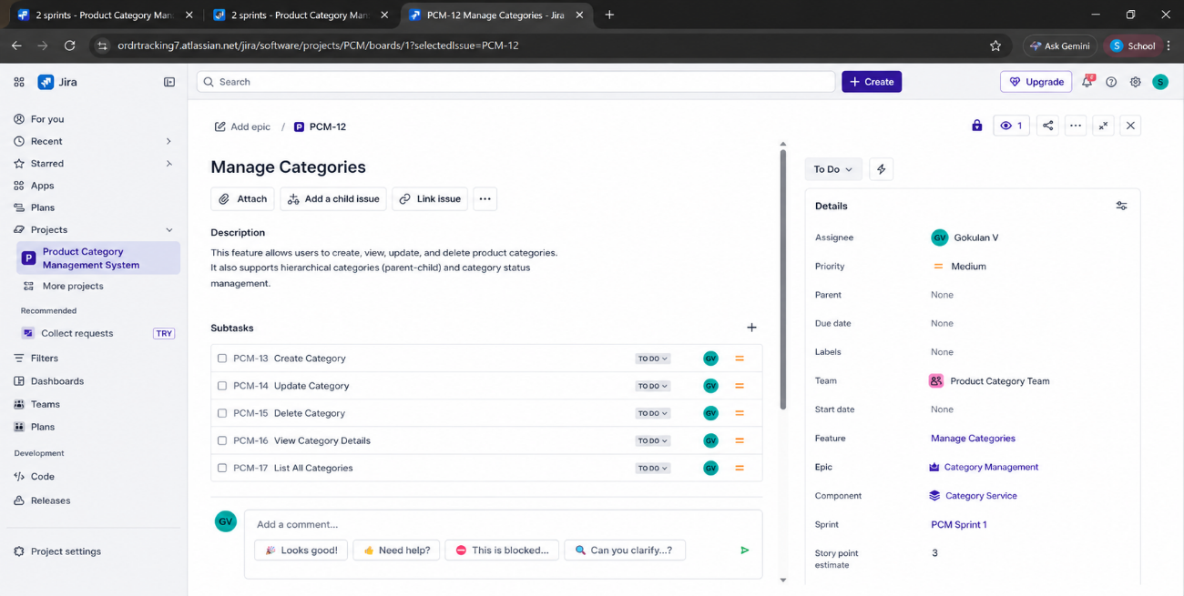
2. Test case
Give two test cases for at least five user stories showcasing the happy path and error scenarios in Azure platform.
Product Tracking System – Test Plans
USER STORIES
- As a user, I want to sign up and log in securely so that I can access the system (ID: US01).
- As a user, I want to place a new product easily (ID: US02).
- As a user, I want to track my product status using Product ID (ID: US03).
- As a user, I want to view complete product details (ID: US04).
- As an admin, I want to view and manage all customer products (ID: US05).

Test Suites
Test Suit: TS01 - User Login
- TC01 – Successful Login
  - Action:
    - Open login page.
    - Enter valid email and password.
    - Click "Login".
  - Expected Results:
    - Login successfull.
    - User redirected to dashboards.
  - Type: Happy Path
- TC02 – Invalid Login
  - Action:
    - Open Login page.
    - Enter invalid email or password.
    - Click on "Login".
  - Expected Results:
    - Error message “Invalid credentials” displayed.
  - Type: Error Path

Test Suit: TS02 – Product Creation
- TC03 – Valid Product Creation
  - Action:
    - Login successfully.
    - Enter product name and quantity.
  - Expected Results:
    - Product created successfully.
    - Product ID generated.
  - Type: Happy Path
- TC04 – Empty Field Product Creation
  - Action:
    - Open product form.
    - Leave required fields blank.
    - Click place product.
  - Expected Results:
    - Validation message displayed.
  - Type: Error Path

Test Suit: TS03 – Product Tracking
- TC05 – Valid Product Tracking
  - Action:
    - Enter valid Product ID.
    - Click Track Product.
  - Expected Results:
    - Current product status displayed.
  - Type: Happy Path
- TC06 – Invalid Product Tracking
  - Action:
    - Enter wrong Product ID.
    - Click Track Product.
  - Expected Results:
    - Message “Product not found” displayed.
  - Type: Error Path

Test Suit: TS04 – View Product Details
- TC07 – View Existing Product Details
  - Action:
    - Enter Valid Product ID.
    - Click view details.
  - Expected Results:
    - Customer name, product, quantity, date and status displayed.
  - Type: Happy Path
- TC08 – View Non Existing Product
  - Action:
    - Enter Invalid product ID.
    - Click "View Details".
  - Expected Results:
    - Message “Product not found” displayed.
  - Type: Error Path
Test Suit: TS05 – Admin Product Management
- TC09 – View All Products
  - Action:
    - Admin Logs in.
    - Open Manage Products page.
  - Expected Results:
    - All products displayed in list format.
  - Type: Happy Path
- TC10 – Unauthorized Access
  - Action:
    - Normal user tries to access admin page.
  - Expected Results:
    - Access denied message displayed.
  - Type: Error Path

3. Test Cases
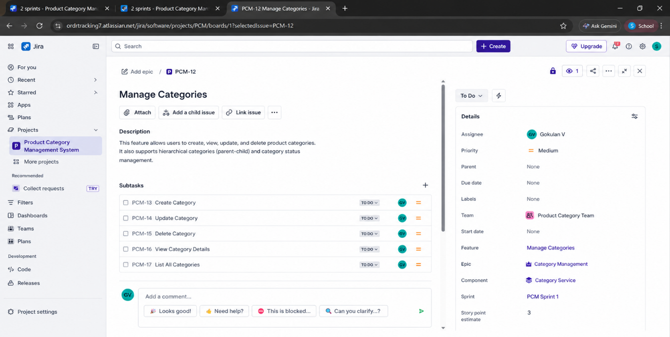

4. Installation of test (Apache JMeter)
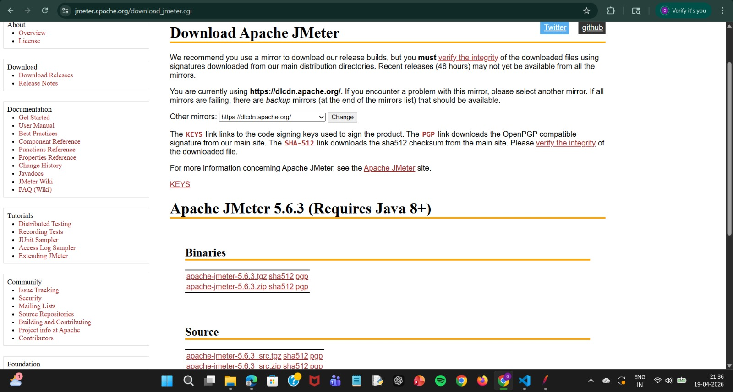
5. Test Plan

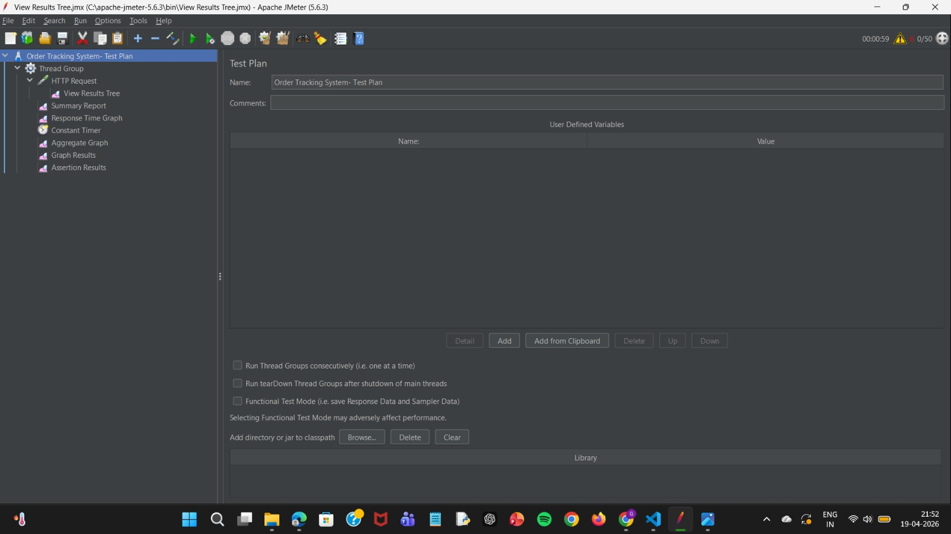

6. Creating the bug
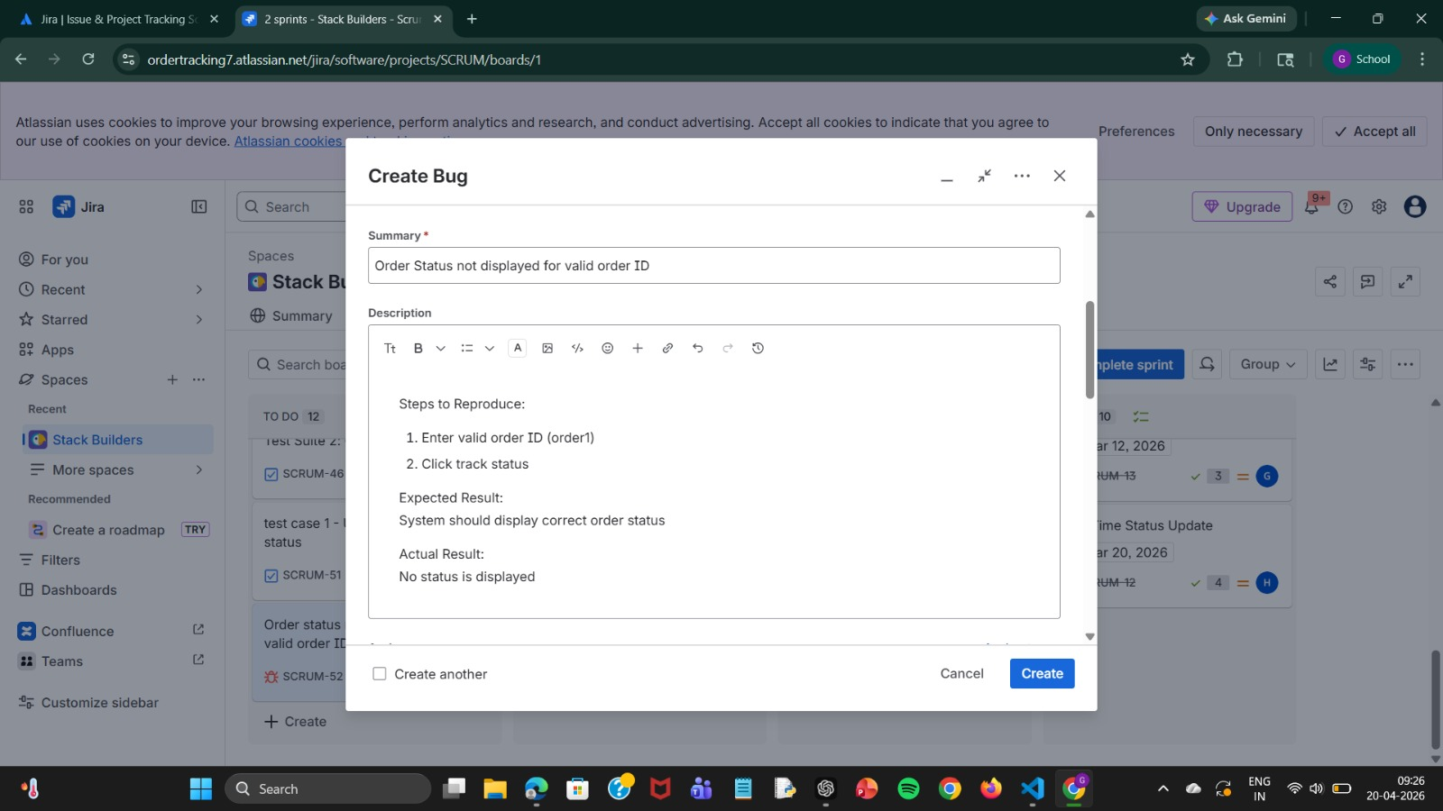

7. Response Time Graph

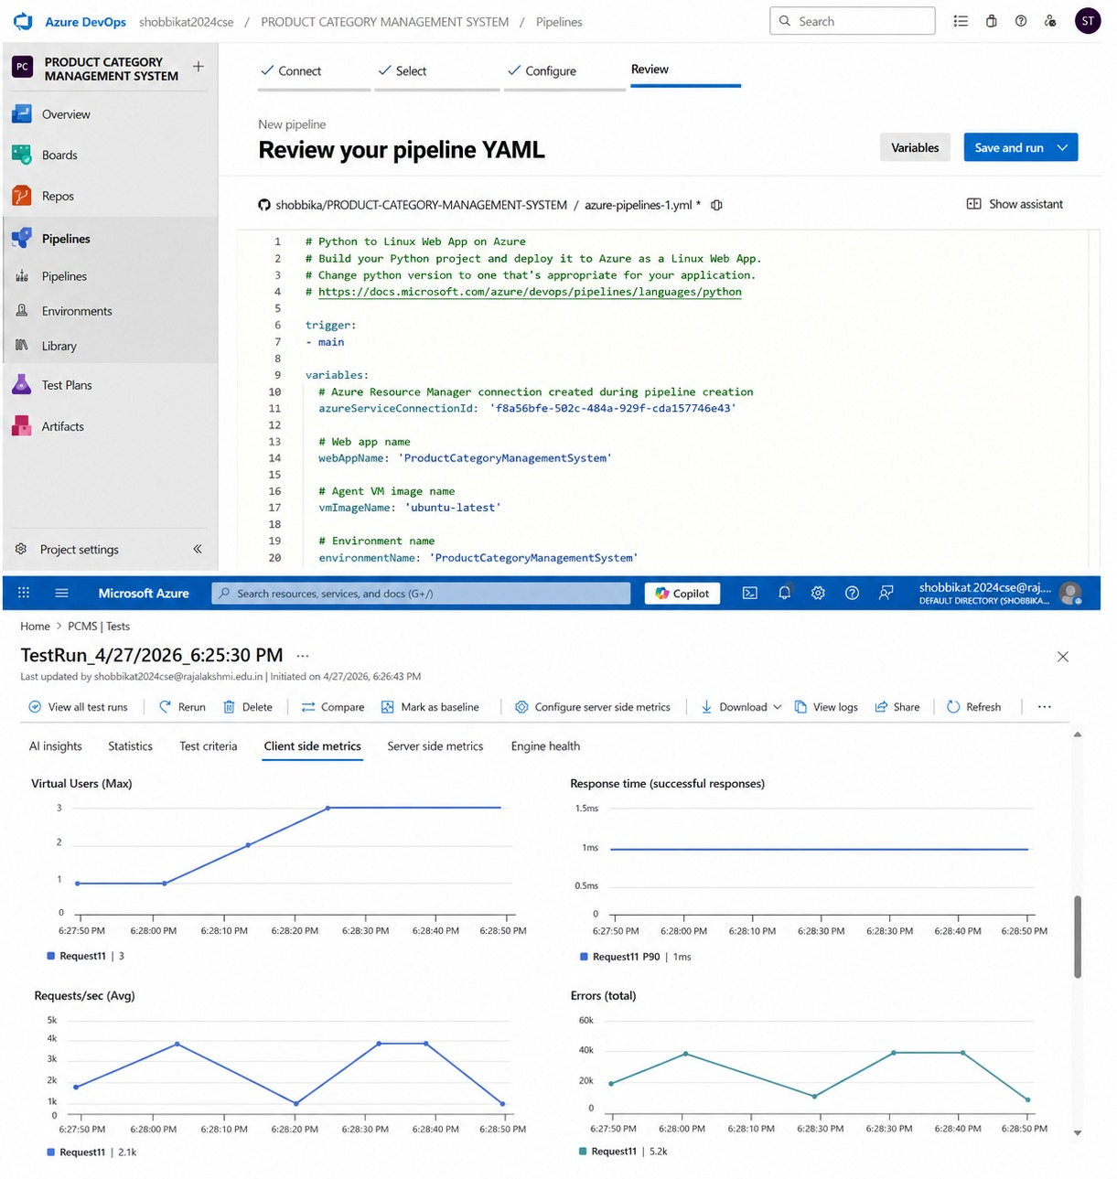

8. Summary report
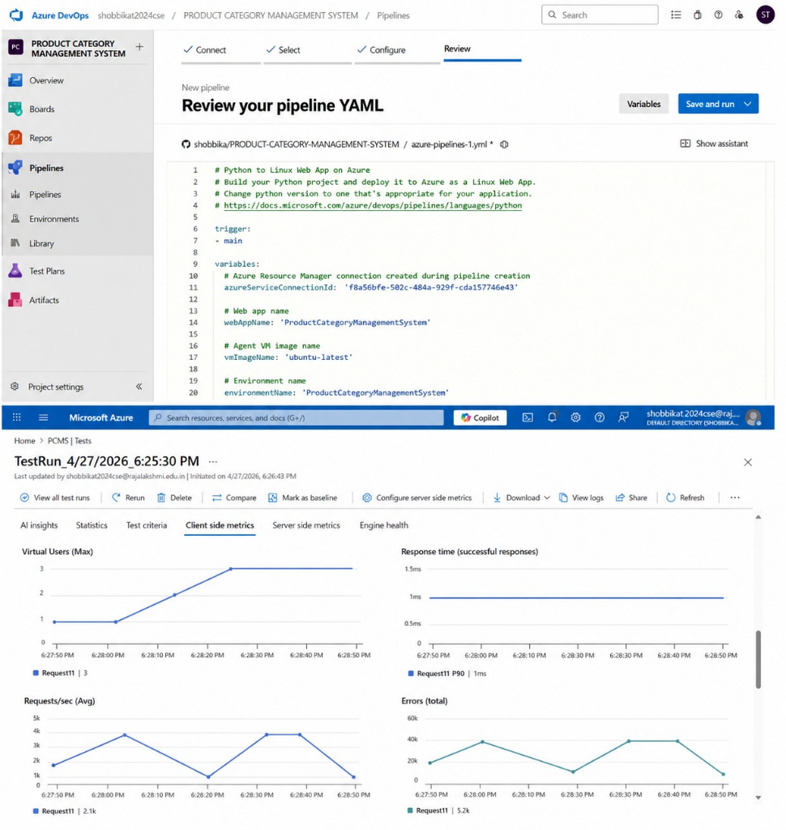

Result:
The test plans and test cases for the user stories is created in Azure with Happy Path and Error Path

EXP NO: 09

LOAD TESTING AND CI/CD PIPELINE SETUP

Create Epic, Features, User Stories, Task

Aim:
To perform load testing for the Product Tracking System and to create and demonstrate a Azure-integrated CI/CD pipeline for automating application builds, tests, and deployment .

Load Testing
Load Testing:
Load Testing is used to simulate multiple users accessing the application simultaneously to evaluate system performance, response time, and stability under heavy traffic. It helps identify bottlenecks, and improve scalability before deployment.

Steps to Perform Load Testing:
- Sign in to the selected load testing tool (Apache JMeter / Locust / online load testing tool).
- Create a New Test Plan
  - Open the tool and create a new test plan.
- Configure Thread Group
  - Number of Users: Enter virtual users.
  - Ramp-Up Time: Set user start time.
  - Loop Count: Set number of requests.
- Add HTTP Request
o Server Name: localhost / deployed server IP.
o Port Number: 8080
o Path: /track?productId=product1
- Add Listeners
o View Results Tree
o Summary Report
o Graph Results
- Save the test plan and click Start.
- Observe performance metrics such as:
o Response time
o Throughput
o Error percentage
o CPU usage

Steps to Create and Demonstrate CI/CD Pipeline:
- Open GitHub repository containing the Product Tracking System source code.
- Open GitHub Actions / CI-CD tool.
- Create a new workflow file.
- Configure pipeline stages:
  - Build Java project using Maven
  - Run test cases
  - Package application
  - Deploy application
- Save the workflow file.
- Trigger the pipeline by pushing code changes.
- Verify successful build, test, and deployment status.

Load Testing

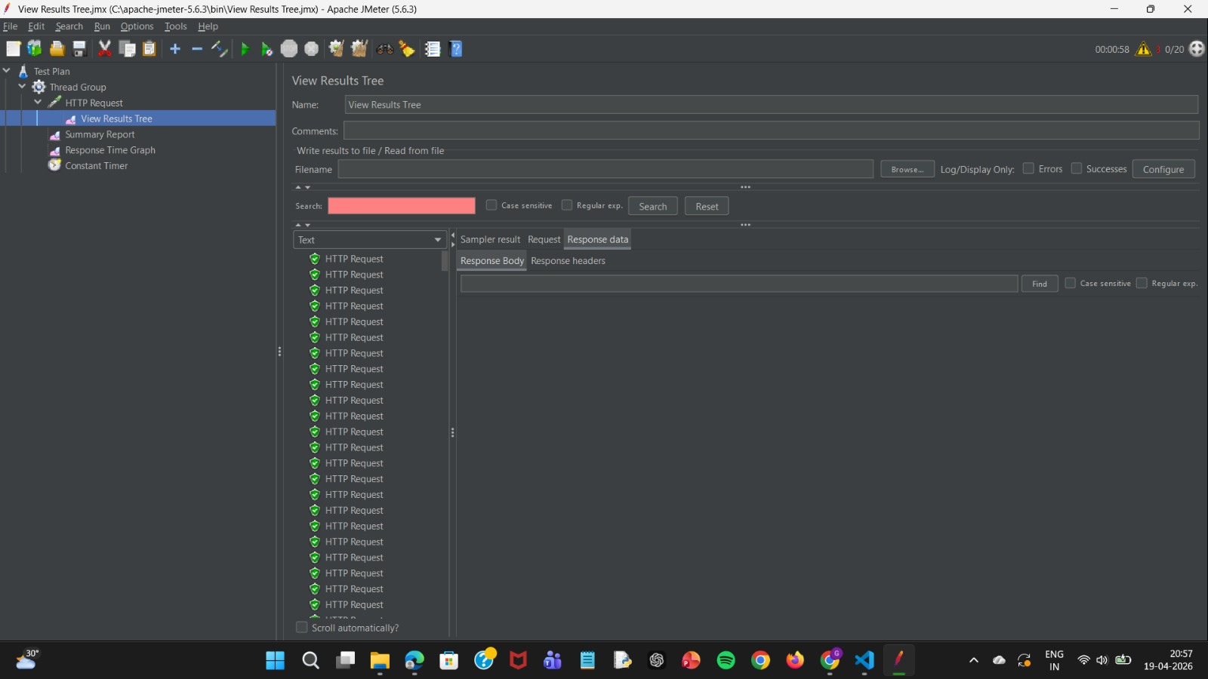

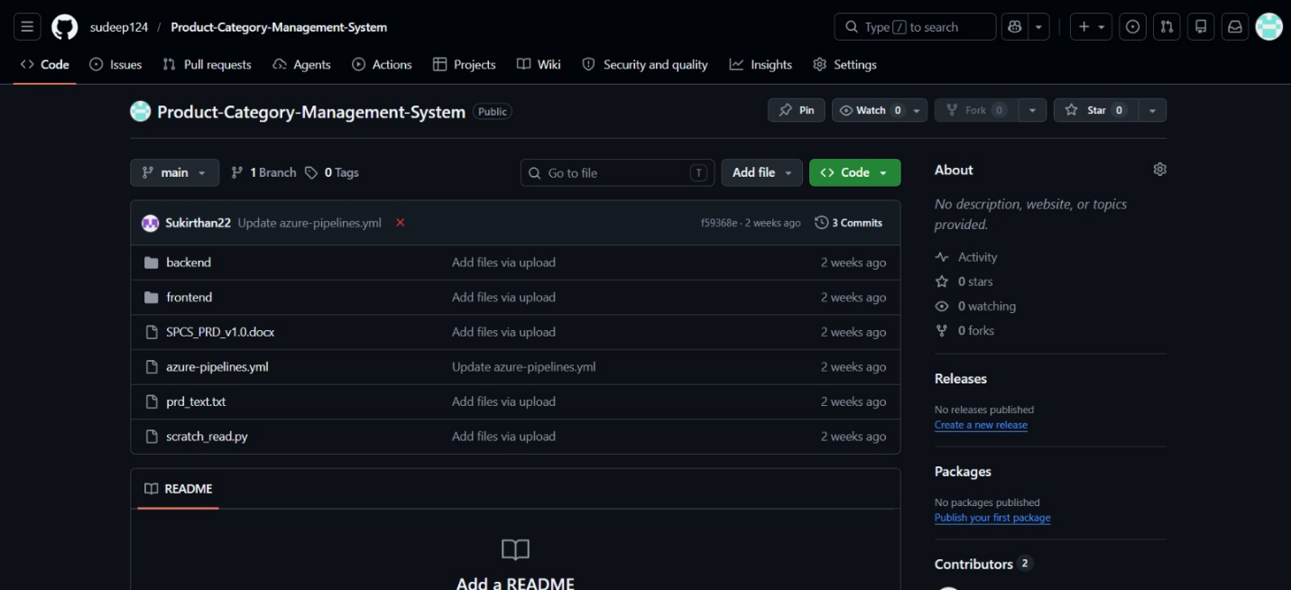
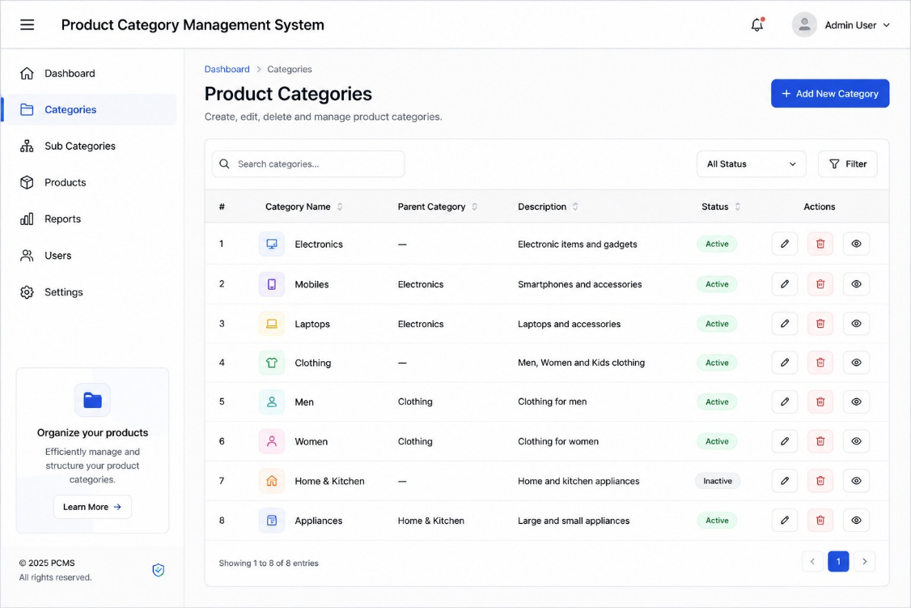

Pipelines

Description:
This experiment demonstrates how to connect a GitHub-hosted Java-based Product Tracking System project with Azure. The pipeline automatically installs dependencies, builds the project using Maven, runs tests, and publishes build results. This ensures every code commit is verified for reliability and smooth deployment.

Steps:
- Connect GitHub Azure:
  - Open Azure project settings.
  - Select GitHub integration.
  - Authorize access to your GitHub repository.
  - Link the repository with the Azure project.
- Create GitHub Actions Workflow:
  - In your GitHub repository, open Actions tab.
  - Create a new workflow file inside:
.github/workflows/main.yml
- Add Pipeline Configuration:
o Configure Java setup.
o Install Maven dependencies.
o Compile project.
o Run tests.
o Package application.
- Commit and Push Code:
o Push changes to GitHub repository.
- Automatic Pipeline Execution:
o GitHub Actions automatically starts pipeline after each push.
- Verify Results:
o Check build success, test results, and deployment status.

Main.yml code
name: Java CI Pipeline

on:
push:
branches:
- main

jobs:
build:

runs-on: ubuntu-latest

steps:

# Step 1: Checkout code from GitHub
- name: Checkout Repository
uses: actions/checkout@v4

# Step 2: Set up Java
- name: Set up JDK 17
uses: actions/setup-java@v4
with:
java-version: '17'
distribution: 'temurin'

# Step 3: Build using Maven
- name: Build Project
run: mvn clean compile

# Step 4: Run Tests
- name: Run Tests
run: mvn test

# Step 5: Package Application
- name: Package Project
run: mvn package

# Step 6: Success Message
- name: Display Message
run: echo "Product Tracking System Build Successful!"

- Pipeline Tasks Include:
- Setting up the Java environment using JDK 17.
- Installing project dependencies and required libraries using Maven.
- Compiling the Product Tracking System source code using Maven build commands.
- Running test cases to verify application functionality.
- Packaging the project into a deployable JAR file.
- Displaying a success message after successful pipeline execution.
- Run and Monitor Pipeline:
- Commit changes to the main branch of your GitHub repository to trigger the pipeline automatically.
- Open the GitHub Actions tab to monitor workflow execution.
- View logs, build status, test results, errors, or success messages and ensure the pipeline runs successfully.

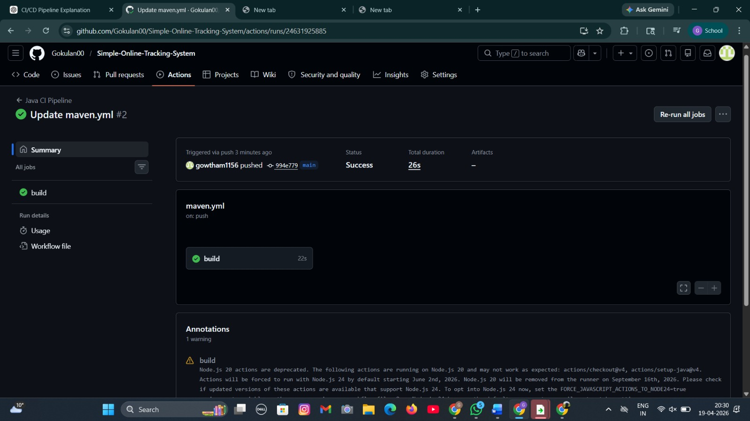
Pipeline

Result:Successfully created the Load Testing resource and executed a load test to assess the performance of the specified endpoint and also demonstrated pipelines in Azure.

EXP NO: 10

GITHUB: PROJECT STRUCTURE & NAMING CONVENTIONS

Create Epic, Features, User Stories, Task

Aim:
To provide a clear and organized view of the project's folder structure and file naming conventions, helping contributors and users easily understand, navigate, and extend the Product Tracking System project.

GitHub Project Structure



Result:
The GitHub repository clearly displays the organized project structure and consistent naming conventions, making it easy for users and contributors to understand and navigate the codebase.

